
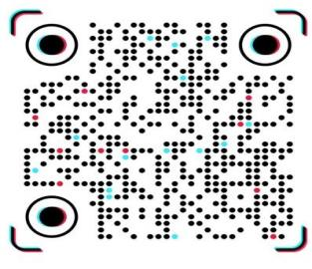Transvaginal ultrasound
Patient Name; Farzana Age: 32 YEAR Date: 30/10/2026
- UTERUS:
Measures 5.7 × 3.5 × 4.4 cm. Myometrial echotexture is homogeneous with no focal myometrial lesion seen.
- ENDOMETRIUM:
Measures 3.1mm in thickness. Endometrial echotexture is unremarkable with no focal lesion.
- CERVIX:
The cervix appears normal with no focal abnormality detected.
- RIGHT OVARY:
Normal in size, measuring 30 × 20 × 15 mm (volume approximately 4.7 mL). Contains 5–6 small follicles. No focal lesion is seen.
- LEFT OVARY:
Normal in size, measuring 30 × 20 × 15 mm (volume approximately 4.7 mL). Contains 5–6 small follicles. No focal lesion is seen.
- ADNEXA:
No adnexal mass or abnormality is identified bilaterally.
- POUCH OF DOUGLAS:
No free fluid is seen in the pouch of Douglas.
- IMPRESSION:
Normal transvaginal ultrasound study.

Dr Spogmai Siddique
MBBS, FCPS (Gynae)


MUHAMMAD MEDICAL COMPLEX PHASE 5 HAYATABAD PESHAWAR

